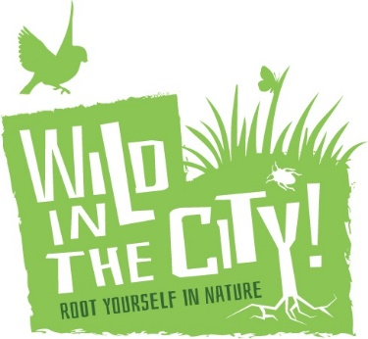
Application Form
Role: Bushcraft Instructor

First Name
Last name
Email
Contact telephone number
Address
Nationality
Do you have a valid work permit? (Yes/No/Not applicable)
Do you have a driving licence (Yes/No)
If yes do you have any penalty points? (How many)
Do you have a Food Hygiene Certificate? If yes, which level?

Why would you like to work for Wild in the City in this role?
Please tell us what relevant experience you feel you have for this role and how you meet the criteria within the person specification?
What are the qualities of a ‘good relationship’ and why are they important?
Tell us a little more about you, what are your interests/hobbies?
Additional information – anything else you’d like us to know?

Please briefly describe your experience, knowledge of methods and skill level for each of these bush crafts
Fire without matches
Water purification

Shelter building

Cordage

Basketry

Knots

Animal tracking and trailing

Natural navigation

Compass navigation

Axe use

Carving/Pole Lathe/Green woodworking

Camp craft;
Setting up and living in camp
Camp hygiene
e.g. latrines

Butchery

Fishing

Campfire cooking

Outdoor first aid

Edible plants

Plant ID

Animal ID

Forest management/ Conservation skills

Canoe/kayaking

REFEREES. Please give contact details for two referees. If you are currently in work, one of these should be your present employer
Name  Address  Phone  Email  Relationship to you | Name  Address  Phone  Email  Relationship to you

Disclosure & Barring Service (DBS) Checks
By law, the appointed post holder must have an enhanced Disclosure and Barring Service check, and be cleared as suitable for working with Wild in the City. Because of the nature of this post, the checks will reveal “spent” as well as “unspent” convictions, in accordance with the Children’s Act. Candidates invited for interview will be asked to send details of any criminal convictions in strict confidentiality, prior to a DBS check being carried out, to be discussed at interview. Please do not send any criminal records information at this stage in the application process.

Please send your completed application form, along with your up to date CV to Beth Collier, Director, beth@wildinthecity.org.uk.

