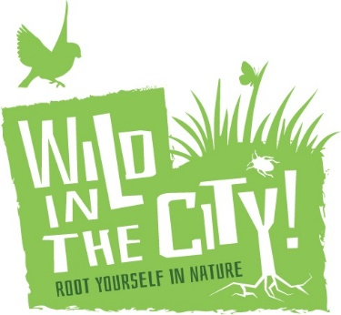
Application Form
Role: Nature Connectors Coordinator

First Name
Last name
Email
Contact telephone number
Address
Nationality
Are you eligible to work in the UK without restrictions?
Do you require a visa in order to work in the UK?
If you hold a current visa, please state from which country the visa was issued, and expiry date if applicable and any restrictions:

Do you have a driving licence (Yes/No)
If yes do you have any penalty points? (How many)
Have you ever been arrested, charged, convicted for any offence? If yes, please give details including year and nature of offence.
How did you become aware of this vacancy? E.g. word of mouth, website,

Why would you like to work for Wild in the City in this role?
Please tell us what relevant experience you feel you have for this role and how you meet the criteria within the person specification? Examples can be taken from work, volunteering or community activities etc.
What are the qualities of a ‘good relationship’ and why are they important?
Tell us a little more about you, what are your interests/hobbies?
Additional information – anything else you’d like us to know?

REFEREES. Please give contact details for two referees. If you are currently in work, one of these should be your present employer
Name  Address  Phone  Email  Relationship to you | Name  Address  Phone  Email  Relationship to you

Please send your completed application form, along with your up to date CV to Beth Collier, Director, beth@wildinthecity.org.uk by 5pm on 25TH April 2018.

